Home Tempature Adjustment System
Software Requirements Specification
For Home Tempature Adjustment System

Prepared by Ahmet Talha Sivrikaya
14.03.2026
«Page Break»

Table of Contents
«Table of Contents»
Revision History
Name | Date | Reason for Changes | Version
Ahmet Talha Sivrikaya | 14.03.2026 | ”Initial version” | «1.0»
Ahmet Talha Sivrikaya | 28.03.2026 | “UML User Case Added” | «1.1»
Ahmet Talha Sivrikaya | 29.03.2026 | “UML Class Added” | «1.2»
Ahmet Talha Sivrikaya | 16.04.2026 | “UML Actvitiy Diagram Added” | «1.3»
Ahmet Talha Sivrikaya | 16.04.2026 | “UML Sequence Diagram Added” | «1.4»
Ahmet Talha Sivrikaya | 16.04.2026 | “UML State Diagram Added” | «1.5»
«Page break»

1. Introduction
1.1. Purpose
The purpose of this document is to introduce the functions and requirements of the Home Temperature Adjustment System. This system contains a user interface and an authorized interface. The technical team can use the authorized interface and users can use the user interface. This document also includes the system’s features and behaviors.
1.2. Document Conventions
In this document main titles writed with bold font. The functional requirements are shown as ‘REQ-1,2’, non-functional requirements are shown as ‘NF-1,2’.
1.3. Intended Audience and Reading Suggestions
This document written for technical team and lecturers. Please read in title order.
1.4. Product Scope
Today, heating and cooling systems in homes are mostly based on manual control and this is not efficient. Forgetting to turn off the heating when leaving the house in the morning or leaving the air conditioner on all day is so common. It causes empty spaces where no one is present to be heated or cooled for hours, resulting in a huge waste of energy and high bills.
Its not only about economic, this situation is not comfortable at all. Classical systems do not include human density. For example, the temperature that is ideal when you are alone at home can suddenly become oppressive when several more people come into the room. Since the system cannot detect this change, you have to constantly go and make manual adjustments on the device.
These traditional methods, damage environment and energy consumption. There is a need for a smart and autonomous system will not require people to constantly think about thermostat settings in daily rush and can detect the number of people in the house and make its own decisions.
The Home Temperature Adjustment System we designed aims to solve this problem by instantly monitoring the occupancy rate in the house. The system will reduce the bill by turning off devices when the house is vacated; when there are people at home, it will maximize comfort by automatically balancing the temperature according to the number of people.
1.5. References
2. Overall Description

2.1. Product Perspective
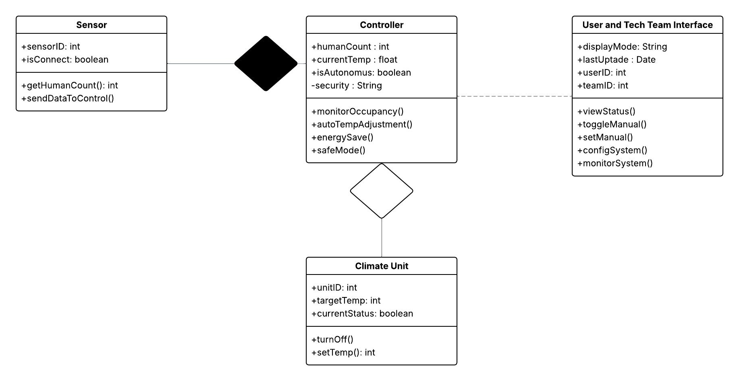
Figure 1

2.2. Product Features
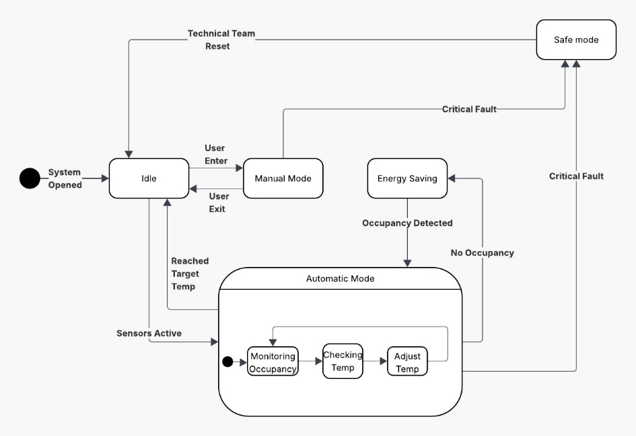
Figure 2

System; It operates in five basic states: Idle, Manual, Automatic, Energy Saving and Safe Mode. In case of any critical error (such as loss of sensor connection), the system automatically switches to 'Safe Mode' and maintains a safe temperature (e.g. 21°C).
2.3. User Classes and Characteristics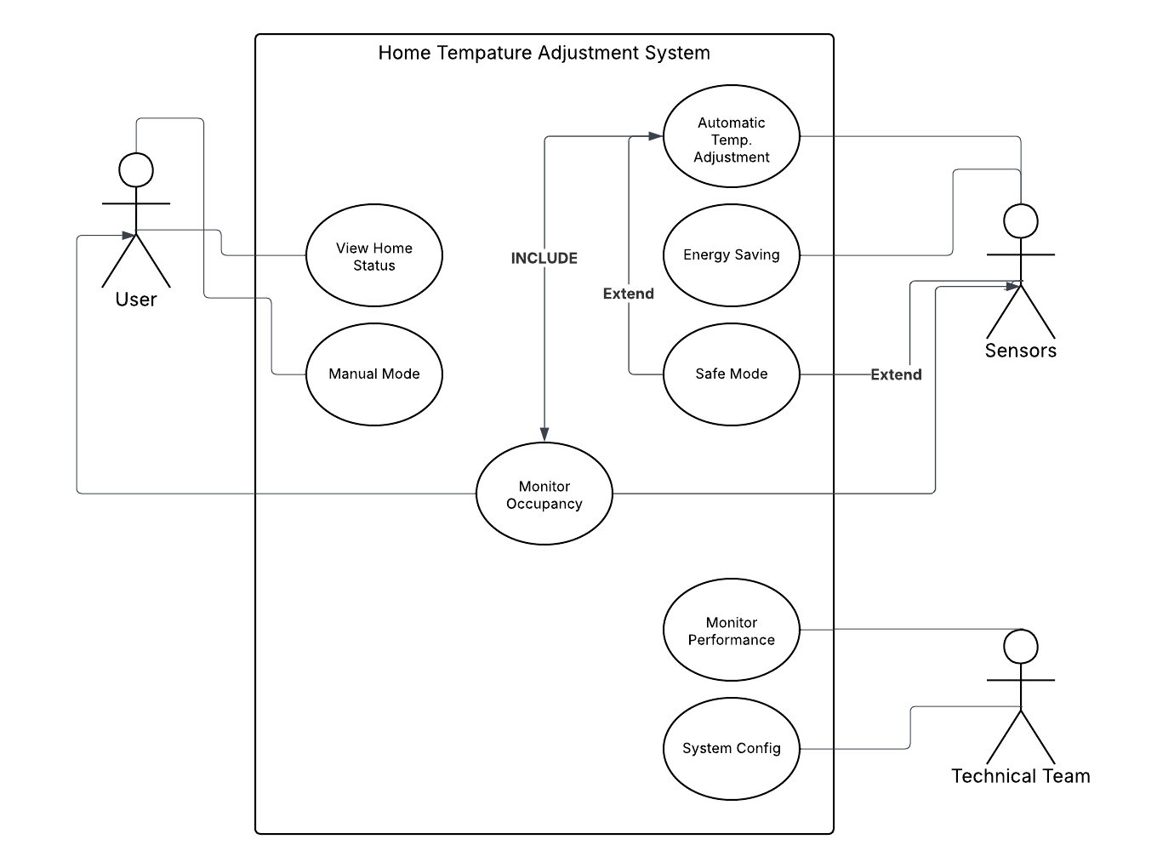
Figure 3
2.4. Operating Environment
2.5. Design and Implementation Constraints
2.6. User Documentation
2.7. Assumptions and Dependencies
3. System Features
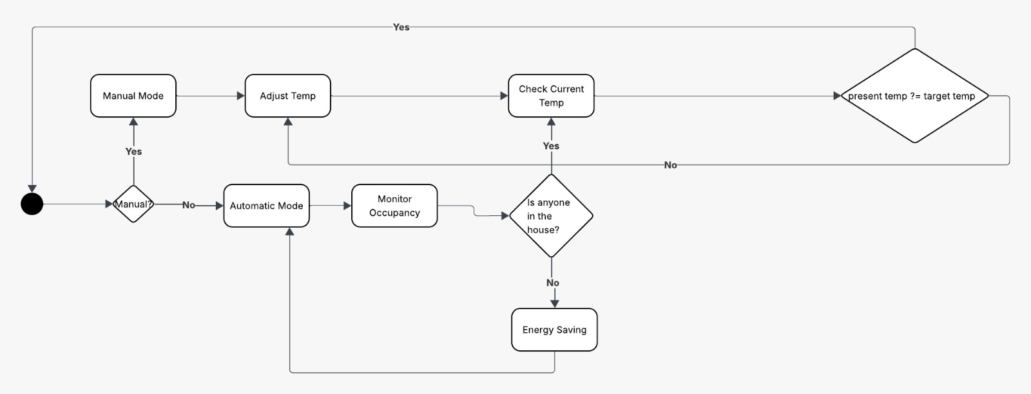
Figure 4
When the system is turned on, the user is given the option of Manual or Automatic mode. In automatic mode, the system constantly monitors the occupancy rate in the house. If there is no one at home, it switches to 'Energy Saving' mode; If someone has it, they adjust the air conditioning unit until it reaches the target temperature.
4. External Interface Requirements
4.1. User Interfaces Overview
4.2. Hardware Interfaces
4.3. Software Interfaces
5. System Features/Modules
5.1 System Feature Name
5.1.1. Description and Priority
5.1.2 Stimulus/Response Sequences
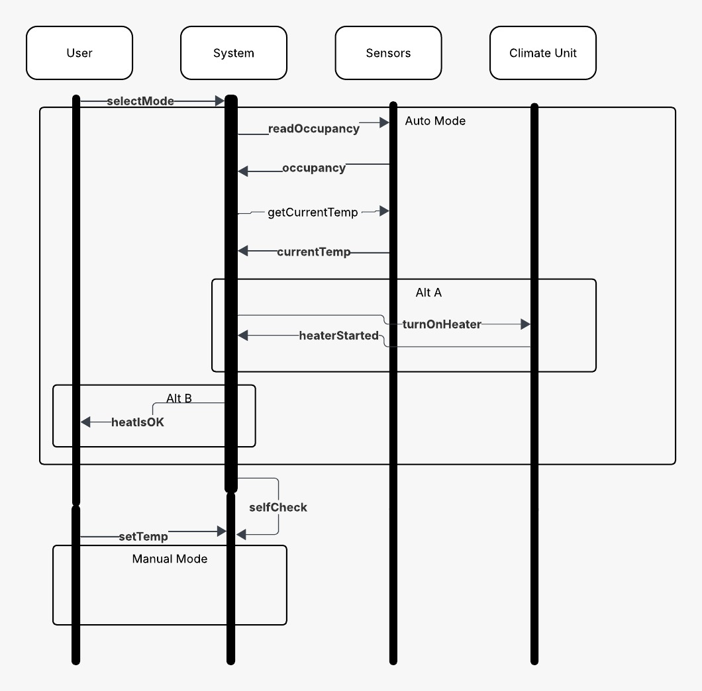
Figure 5
The system reads occupancy and currentTemp data from the sensors. If automatic mode is selected, it sends the turnOnHeater command to the air conditioning unit based on this data. If the user wishes, he can switch the system to manual mode with the setTemp command.
5.1.3 Functional Requirements
REQ-1.1: System shall detect human count in the house using sensors.
REQ-1.2: When human count in house is zero system, shall turn of the all climate units
REQ-1.3: When the number of people in the house increases or decreases, the system shall dynamically adjust the temperature.
REQ-1.4: The system shall allow the user to disable autonomous mode and enter manual temperature via the interface
REQ-1.5: If the sensor is disconnected, the system shall enter safe mode and operate at a standard temperature (e.g. 21°C).
6. Nonfunctional Requirements
6.1. Performance
NF-1.1: The system shall process the data from sensors < 3 seconds and send commands to the climate units.
NF-1.2: The situation of house shall recorded securely using encryption.
6.2. Security
NF-2.1: The system shall start automatically after the blacouts.

